# Technical Report

# Malaria Trends and Intervention in Africa Analysis Report (2007-2017)

# 1. Introduction

Malaria is a common disease in Africa. The disease is transmitted to humans through infected mosquito bites. Although you can take preventive measures against malaria, it can be life-threatening. This dataset includes the malaria cases in African countries, the incidence at risk, and data on preventive treatments against malaria. The report of the analysis will provide in depth analysis of the Malaria trends and interventions in Africa. The insights from this report could help the health sectors in these countries plan their malaria intervention programs, reduce the mortality from malaria, explore innovation and strategy that the successful countries have used in managing their malaria disease. This report can also stand as an advocacy tool for the engagement of different Governments for increased funding of their malaria programs.

## Objective of the Project

The project aims to achieve the following objectives:

* Analyze Malaria treatment trends to gain meaningful insights that could help improve intervention.
* Determine the level of use of insecticide-treated net as a preventive mechanism for malaria prevention.
* To identify the incidence rate of malaria disease in Africa countries and the intervention implemented.
* Examine the use of Intermittent preventive Treatment (IPT) by pregnant women.
* Establish the relationship between safely managed drinking water services and the number of reported malaria cases.

## Overview of Data and Methodologies

The project is based on the in-depth analysis of Malaria trends and interventions dataset sales. The dataset covered the following areas:

* Malaria Cases Reported -This details the prevalence of malaria in the different countries irrespective of the interventions.
* Antimalarial Medication used in Children- this showcases the level of intervention in the children population.
* IPT used in Pregnancy women- showcases the level of maternal health in the countries.
* Malaria cases per year-To determine the year with better intervention and replicate such in other years.

# 

# 2. Story of the data

The dataset include data on all African Countries from 2007-2017. The incidence of Malaria is a variable that counts the number of Malaria cases per 1000 people in areas where Malaria transmission occurs. This malaria case reported includes the number of malaria cases that have been confirmed by examination. In addition, the dataset includes preventive measure that have been taken to prevent malaria, such as the use of insecticide -treated bed nets, the percentage of children with fever receiving antimalarial medication, and the percentage of pregnant women receiving preventive treatment

The data on the incidence of malaria, malaria cases reported, and preventive treatment against malaria were retrieved from the world bank open data source.

The data was structured in tables containing **594 entries** and **27 columns**. It includes data on malaria incidence, cases reported, intervention strategies (e.g., insecticide-treated bed nets and antimalarial drugs), access to water and sanitation, and demographic factors like rural and urban population growth. However, many columns contain missing values.

Key features of the data are:

* Antimalarial Treatment by Children per Year
* Countries Malaria Incidence Rate
* Safely Managed Sanitation Services by Countries
* Reported Malaria Cases by Countries
* IPT use in Pregnancy by Countries
* Safely Managed Drinking Water Services by Countries
* Insecticide Treated Net by Children per Year
* Malaria Reported Cases per Year.

The dataset did not provide information on the funding sources that supported the interventions, this information would have been vital to help denote the fluctuation in the trend of malaria interventions by use of antimalarial medications and insecticide treated net in children.

# 3. Data Splitting and Preprocessing

The data was observed and found to be clean, and did not have duplicates, inconsistent variables or empty rows. However, there was missing data in some columns.

A pre-processing stage of data splitting was carried out by dividing the data into two data categories: dependent and independent variables.

* **Independent Variables** - Country Name, Country Code and Year
* **Dependent Variables**- Incidence Rate, Malaria Reported Cases, Use of Insecticide treated Net, Children with Fever receiving Antimalaria, IPT in Pregnancy, Safely Managed Drinking Water Services, Safely Managed Sanitation Services, Rural Population, Urban Population, Rural Population Growth, Urban Population growth.

**Industry Context**

Health Data showing Malaria trends and interventions in Africa. Health sector data

## 

## Key stakeholders

## The State Ministry of Health, Federal Ministry of Health, National Malaria Elimination Program, donor agencies and key public health stakeholders

## 

## Value to the Industry

Success for this industry means a cost-effective implementation of interventions to reduce the burden of malaria among the susceptible groups (Children and Pregnant women).

# 4. Pre-Analysis

## Key Trends

The pre-analysis focuses on preliminary trends and patterns derived from the dataset before an actual analysis is conducted. Key trends on Antimalarial medications use in children, IPT used in pregnant women, malaria cases per country, malaria incidence rate per country and malaria cases per year

Potential Correlations

Based on the preliminary trends and patterns, some potential correlations in the relationship of the variables were derived:

* Best product type by revenue
* Number of children receiving antimalarial treatment Per Country
* Children that received antimalarial treatment per year
* Countries with the most malaria cases
* Countries with the most incidence of Malaria
* Insecticide Treated-Net intervention per year
* IPT intervention for pregnant women by country
* Countries with most safely managed sanitation services
* Countries with the most safely drinking water services
* Year with the best malaria intervention
* Malaria cases per year
* Malaria cases per rural population
* Malaria cases per urban population

## Initial Insights

The preliminary trends, patterns and potential correlations helped in the generation of some initial insights:

* Identify the best -selling product type and ensure the uninterrupted availability of this product stock to help maximize revenue and profits.
* Government contribution to the supporting malaria intervention per year
* Performance of Government with reducing the incidences and cases of malaria
* The best year with malaria intervention (antimalaria and Insecticide Treated Net) and how this can be replicated in other years
* The population location at highest risk of malaria infection, Urban or Rural
* Formulation of policies that can result in equity in the treatment and prevention of malaria bringing in equity and equality.

# 5. In-Analysis

# Unconfirmed Insights

After the analysis, several unconfirmed insights emerged,

* The year 2010(785.6) and 2014(743.3) accounted for the highest use of antimalarial treatment by children in the management of malaria cases.
* However, there a sharp decline from 2010 to 2013 which may indicate a drop in financing, procurement and scaling up of the testing for malaria
* Ghana (165.59) and Zambia (146.80) had the highest use of Intermittent Preventive Treatment (IPT) in pregnancy and among pregnant women
* Togo presented with the lowest IPT use for all 6 top countries
* Burkina Faso had the highest malaria incidence rate of over 5000 (5.3K)
* The highest use of Insecticide Treated Net by Children was in 2010 (785.6) and 2014(743.3)
* There seem to by a fluctuation on the trend for the use of ITN by children from 2007 to 2017 with a deep rise in 2010 and sustained drop after that year
* The peak for malaria cases was 2017 (128.1Million cases) and 2016 (123.3Million cases), both years are bottom for most of the interventions.
* The lowest cases of malaria were recorded in 2007 (10.1 million cases)

10. Democratic Republic of Congo leads in the burden of malaria disease and recorded the highest case of malaria (over 78 million cases)

## Recommendations

A deep dive into the initial insights led to the generation of recommendations

* Strengthen Insecticide -Treated Net Distribution: Despite higher ITN usage, its impact on malaria incidence appears weak. This suggests that proper net usage education and sustained coverage should be prioritized.
* Improve Treatment Accessibility: Inconsistencies in antimalarial drug coverage should be addressed to ensure prompt treatment for all children with fever.
* Increase case management efforts, including rapid diagnosis and treatment
* Expand Maternal Interventions: The low uptake of IPT in pregnancy suggests the need for targeted campaigns and better integration with antenatal care services.

## Analysis Techniques Used in Excel

The analysis of the data was carried out using Microsoft Excel and taking advantage of the Pivot tables function. Key techniques used in excel were:

* Filtering and sorting - This was used in the analysis of top countries with malaria incidence rates and top countries by malaria reported cases.
* Comparative analysis using bar and column charts- Reported malaria cases per year and countries with most use in IPT for pregnant women
* Pie and Doughnut Charts -perfect for showing part of a whole as applied in analyzing Safely managed water and Sanitation services by top 4 countries.

# 6. Post-Analysis and Insights

The Data analysis post -analysis provided key insights into Malaria trends and interventions in Africa. The following were the insights from the analysis:

**Malaria Preventive Interventions**

* The use of IPT in Pregnant women shows Ghana (165.59) leading the other countries. This performance is closely followed by Zambia (146.30) and Malawi (115.00)
* Togo (81.99) had the lowest among the top 6 countries in the use of IPT.
* The use of Insecticide -treated net by children indicated that 2010 (785.6) and 2014 (743.3)
* 2011 to 2013 had a significant drop in the use of ITN by Children.

**Antimalarial Treatment**

* The highest dosage of antimalarial treatment among children occurred in 2010(696.1), from 2010 to 2013 there was a sharp decline.
* The peak in 2010 suggested a successful malaria intervention campaign and decline after this year, indicating a reduction in drug availability, accessibility and effectiveness of the case management process and intervention.

**Malaria Prevalence in Africa**

* The countries with the most reported malaria cases are Democratic Republic of Congo (DRC) with over 78 million cases, Mozambique (44 million) and Tanzania (24 million) in the analysis of top 8 countries.
* Malaria cases had its highest incidence in the year 2017 and 2016.

**Environmental Factors**

* Tunisia is the country with the most use safely managed sanitation and drinking water services

# 7. Data Visualization and Charts

Dashboard for Malaria Trends and Interventions in Africa Analysis Report (2007-2017)

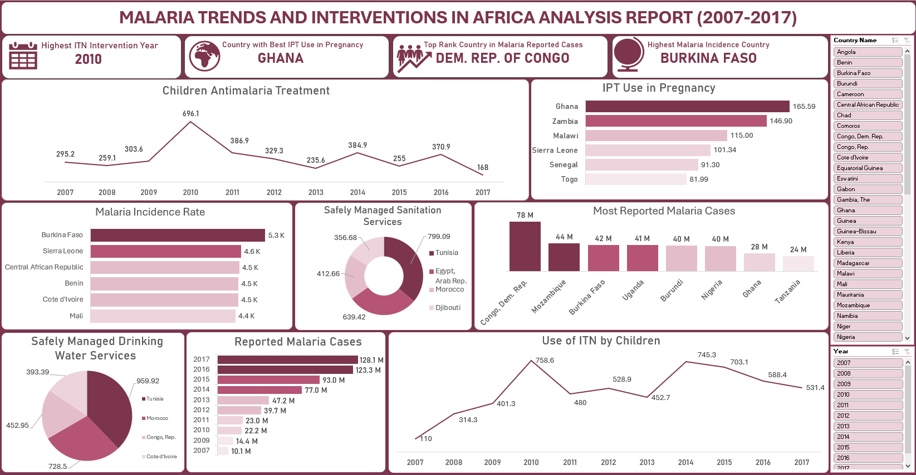

* Chart 1: Antimalarial Use in Children by Year

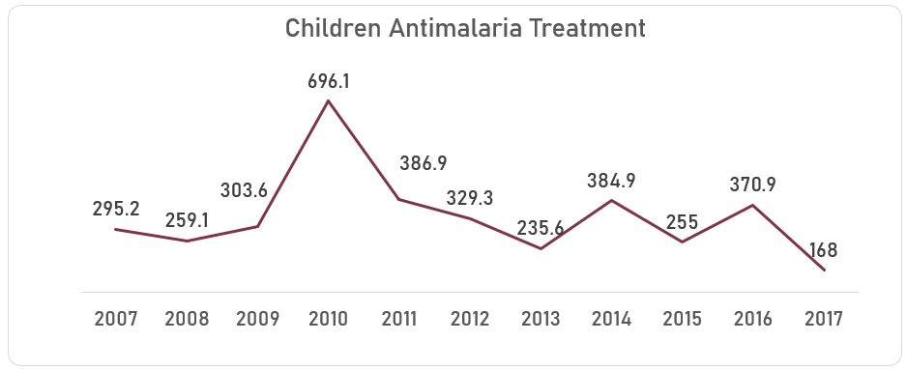

This chart is showing the antimalarial medication used by children in managing children reporting with fever.

Chart 2: Countries with most reported malaria cases

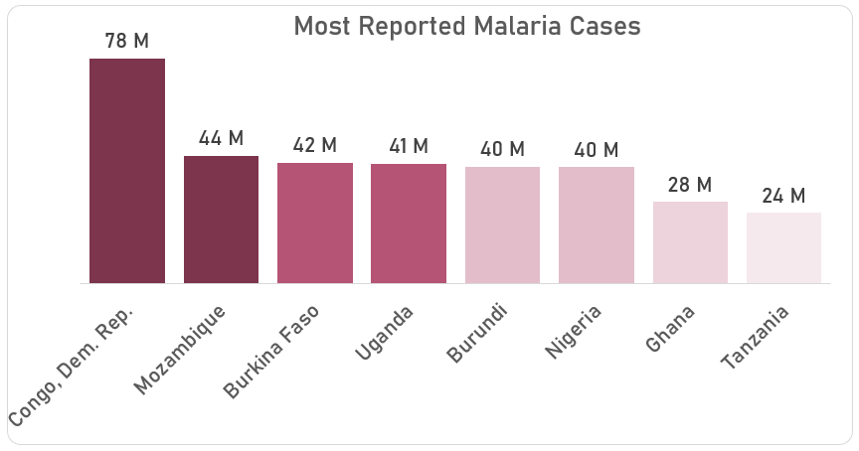

This chart gives insight to the number of malaria cases reported by each country, this gives an indication of the malaria burden in the different countries.

Chart 3: Countries by Malaria Incidence Rate

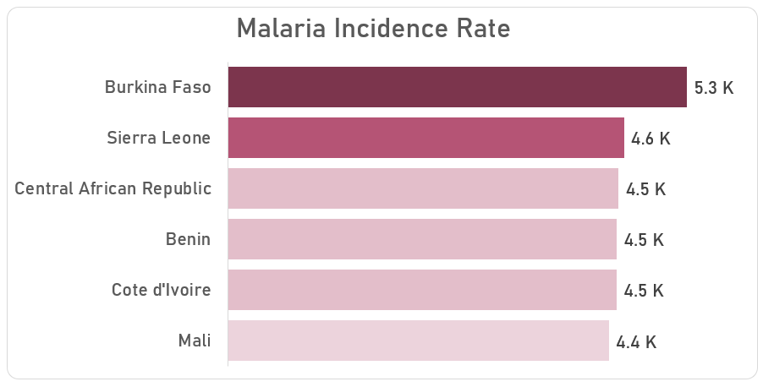

Top 6 Countries by Malaria Incidence rate showcased in this chart with Burkina Faso having the highest incidence rate of above 5.3 thousand.

Chart 4: Most insecticide treated Net use by Children per year

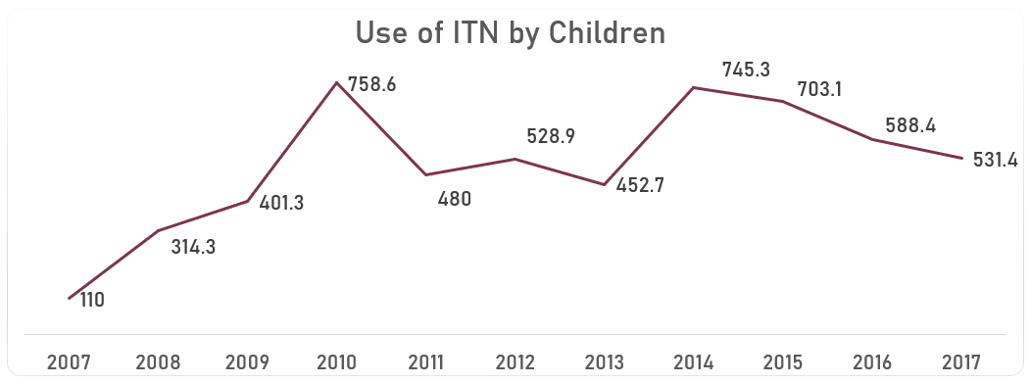

2010 and 2014 showed greater values than other years, indicating that top interventions were implemented in both years.

Chart 5: Most use IPT in Pregnancy by Countries

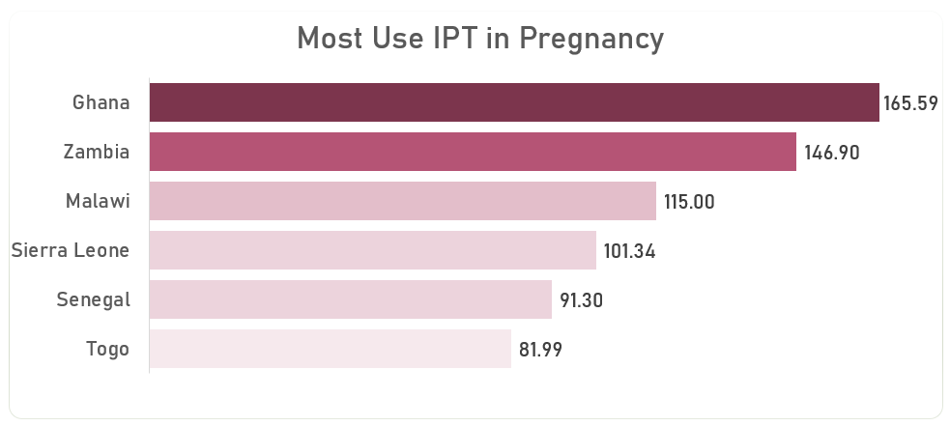

Top 6 countries in the use of IPT in Pregnancy. Here Ghana top the chart, an indication of good maternal healthcare services in this country

Chart 6: Most use Safely Sanitation Services by Countries

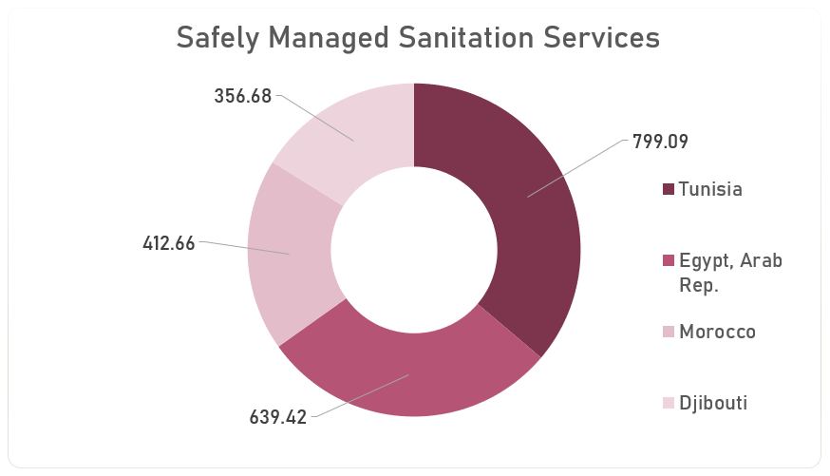

This is the most use safely Sanitation services by Countries.

Chart 7: Most Reported Case per Year

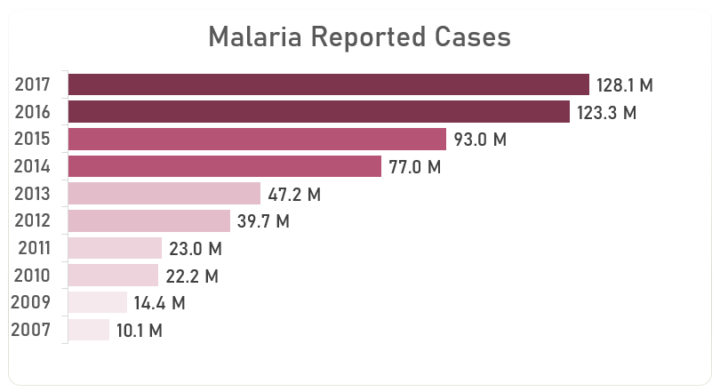

This is the Malaria reported cases per year with 2017 and 2016 showing the highest cases.

Chart 8: Safely Managed Drinking Water Services by Countries.

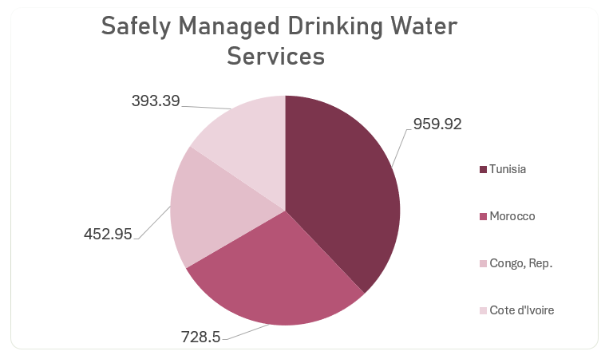

This chart shows countries with the best safely managed Drinking water services.

# 

# 8. Observations and Recommendations

## Observations

* The use of ITNs aligns with high Malaria prevention efforts in 2010, also reflected in high ITN usage and antimalarial treatment rates.
* Access to clean water correlates with better health outcomes, including reduced malaria cases
* The peak in 2010 in the use of antimalarial treatment in children is an indication of a successful intervention program.
* Countries with higher IPT coverage, suggest successful maternal malaria prevention programs.
* The high burden of Malaria in West African Countries suggests a need for intensified malaria control programs
* The increase in reported malaria cases suggest either an improved detection or resurgence in malaria transmission with the National and state Ministries of health taking the lead.
* Central and West African Countries demonstrated high -burden areas for Malaria cases reported, these might be due to poor access to healthcare and prevention interventions programs.

## Recommendations

* Each country should scale up effective interventions like indoor residual spraying (IRS) and Artemisinin-Based Combination Therapy (ACTs)
* Focus global funding and donor funding and intervention efforts on these high-burden countries.
* Improve data collection and reporting mechanism for better monitoring and evaluation of the intervention programs.
* Improve water services in malaria endemic areas and ensure safer sanitation services are also operational.
* Explore the implementation interventions that worked in 2010 and replicate those strategies in other future years.
* Ensure consistent national government funding for ITN distribution programs while carrying out educational and usage training to improve acceptability and application.

# Conclusion

The dataset indicates varying levels of interventions and preventive measures in the fight against Malaria. While most countries are winning in the battle field against malaria, some other countries are slowly lagging behind. The insights drawn from this analysis should be applied in strengthening countries' response to the Malaria disease. There is a need to sustain existing intervention with less reliance on foreign aid or donor funding. Countries Government should take bold steps and budget funds to implement and sustain intervention programs like IPT and ITN. With a greater portion of the health budget of all countries channel towards infrastructurally upgrade and program interventions, Africa in no time will win this fight against malaria.

Reference

Dataset is from Kaggle (<https://www.kaggle.com/datasets/lydia70/malaria-in-africa> )